Intermediate Winning Strategies

Situational Awareness
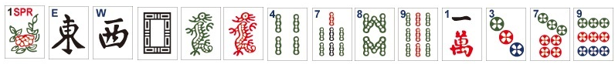 |  |  |  |  | Multiple
 |  |  |  |  | Predominant Pattern
Plan A: |  | Justification:
Plan B: |  | Justification:
Notes:

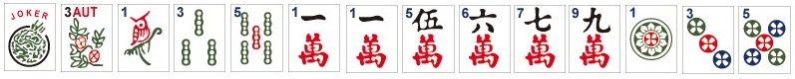 |  |  |  |  |  | Multiple
 |  |  |  |  |  | Predominant Pattern
Plan A: |  | Justification:
Plan B: |  | Justification:
Notes:

Charleston Decision Making (BONUS)
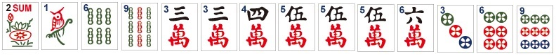 |  |  |  |  | Multiple
 |  |  |  |  | Predominant Pattern
Blind (Y/N): |  | Justification:
Pass:

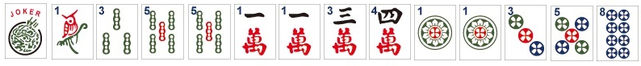 |  |  |  |  | Multiple
 |  |  |  |  | Predominant Pattern
Stop (Y/N): |  | Justification:
Pass:

Outside In/Inside Out
 |  |  |  |  | Multiple
 |  |  |  |  | Predominant Pattern
Blind (Y/N): |  | Justification:
Pass:

 |  |  |  |  | Multiple
 |  |  |  |  | Predominant Pattern
Stop (Y/N): |  | Justification:
Pass:

Lessons Learned

